VICTORY vs. WASHINGTON IRVING
Clarksburg rivals, Victory & W. I. played 51 times between 1921 and 1972. Although we were the smaller school - Victory held the edge in its 51-year series against WI: 28-16-7. VHS won 11 out of the last 13 games.
The first WI-Victory football game I attended was in my junior year on Saturday, November 1, 1944. The two teams played regardless of the weather conditions on Armistice Day. I remember in 1950 it was real warm and sunny, and I just wore a regular shirt. Victory lost this game by a score of 34-0. Because of the seating capacity, all the games were played at the WI Field, later renamed "Hite Field" in honor of WI Coach, Clay B. Hite.
Victory's first home field was in nearby Cole Park, just below the Hazel-Atlas Glass Plant, which only had one set of bleachers on the south side of the field. This field was used from the fall of 1919, until the fall of 1923. On November 23, 1923, the Board of Education purchased property for a new football field on the Gore farm in the community of Gore for $15,000.00. In later years, it was used as Victory's practice field.
Victory holds the edge on in its 51-year series against WI: 28-16-7. (No game was played in 1923.) The last tie game was in 1970 at 6-6. The last game that WI won was in 1968 at 20-14. WI won the first game in 1921, at 35-0, but Victory won the final game in 1972 by the score of 62-12. - Fred G. Layman, Class of '46
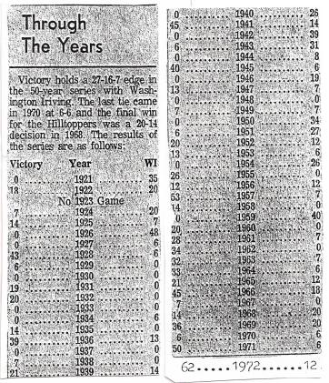
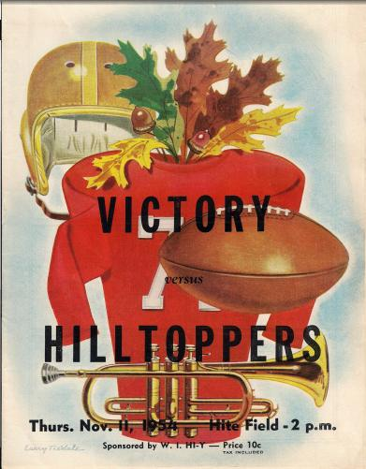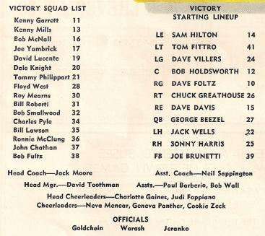

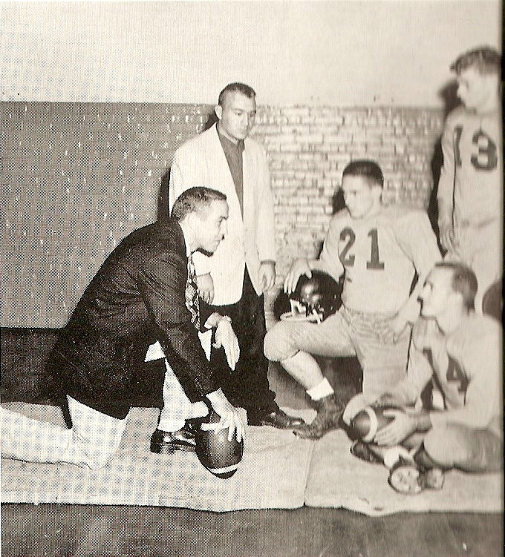
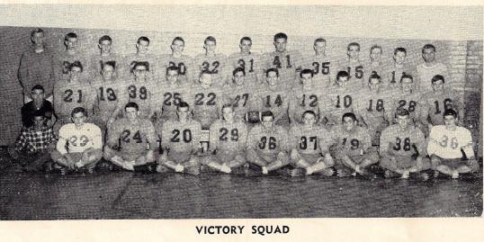
Above: 1954 Victory High School Team
Left: 1957 Football Coaches & Tri-Captains.
Kneeling: Head Coach John Mazzei with Asst. Coach Alessi looking on. Captains: Tom Fittro (on knee), Francis "Turtle" Knight (seated) and Dennis Duncan (standing)

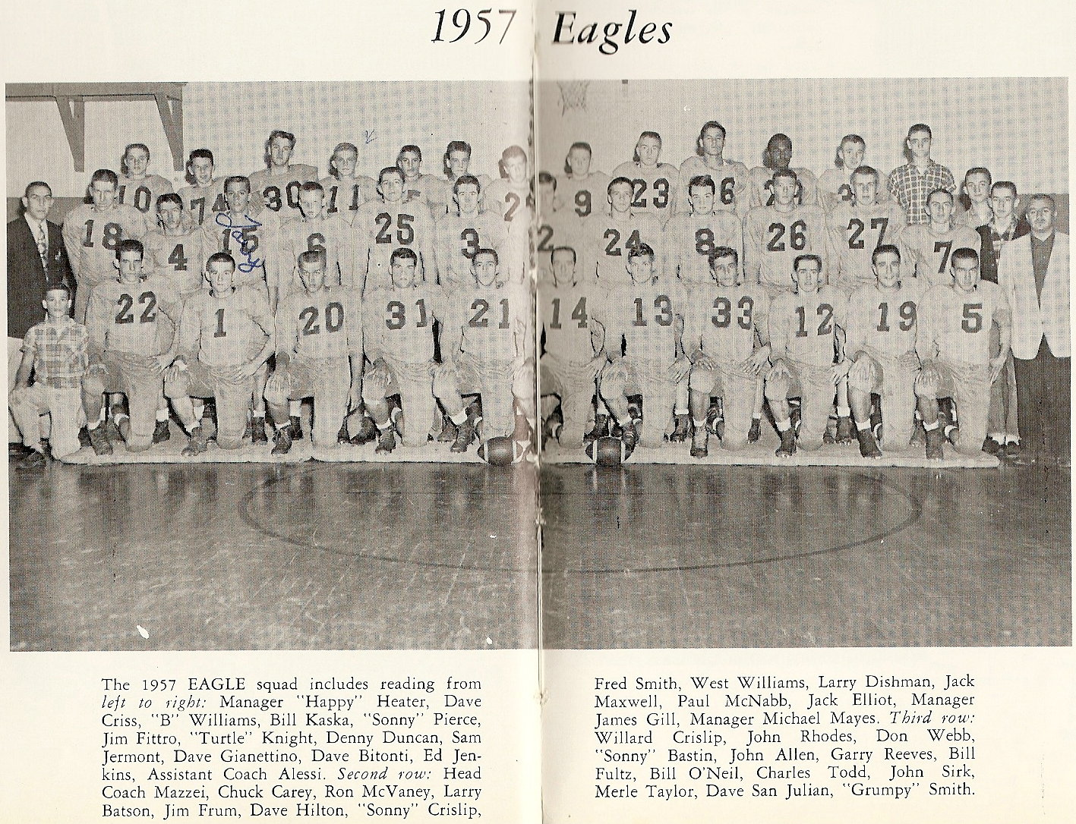
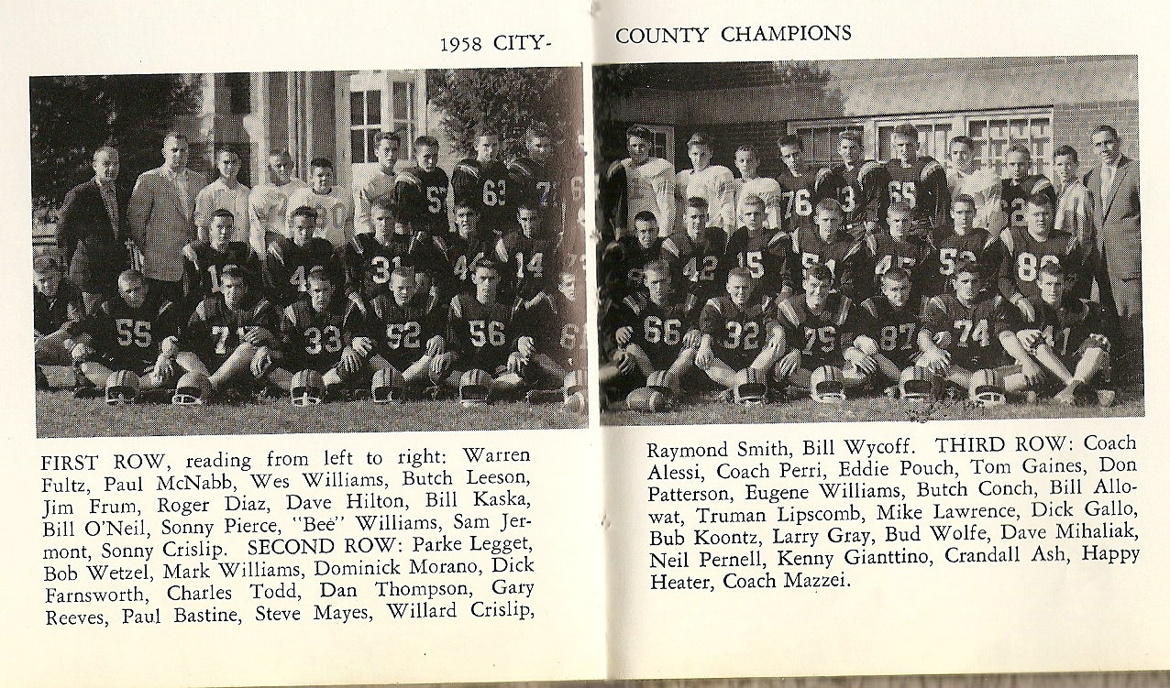

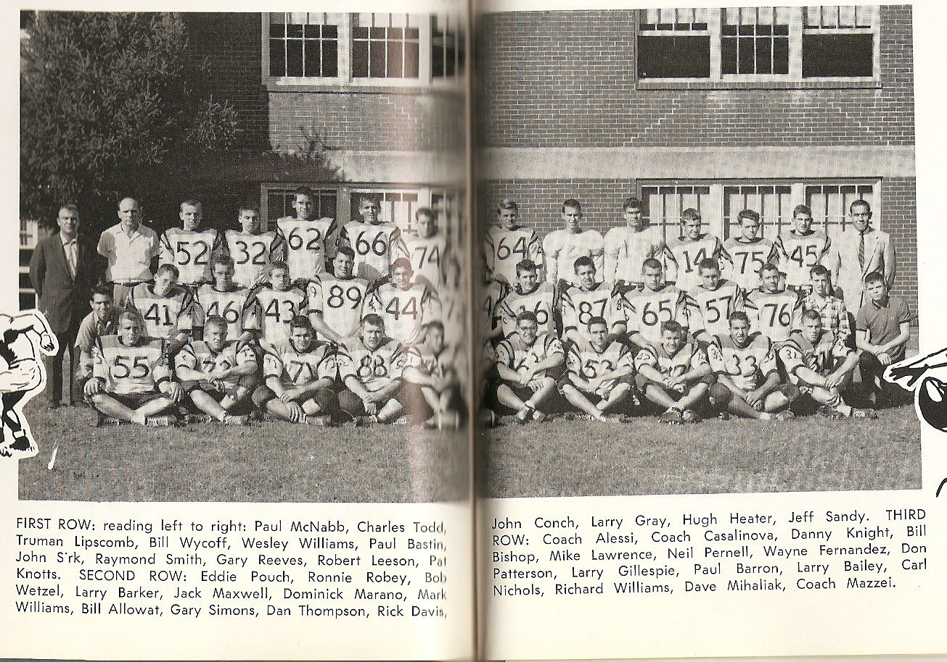
The 1959 Victory High School Football Team "did us proud" with their 6-2-1 record.

